## *User Scenario: Two Step Approval and Review*

We want to implement a user scenario requiring that the overall approval for an artifact such as a business item consists of two different approval steps issued by two different departments: First the item is to be approved based on a technical evaluation by a technical department and after the technical feasibility has been confirmed, a second approval is required by the financial department as to whether the item can be implemented fiscal wise.

As the basis for our new scenario we use the template “ApprovalAndReview.bpmn” which comes provided with your IBM_PRODUCT_NAME and can be found in ???. This original workflow template already contains a single “Approval” task. For the purpose of this scenario we extend the template and add another approval task in order to support the two step approval process.

In the following we describe the steps that you need to perform when adding a new activity to your workflow template. As a prerequisite for these steps, start your workflow visual editor and import this template “ApprovalAndReview.bpmn”.

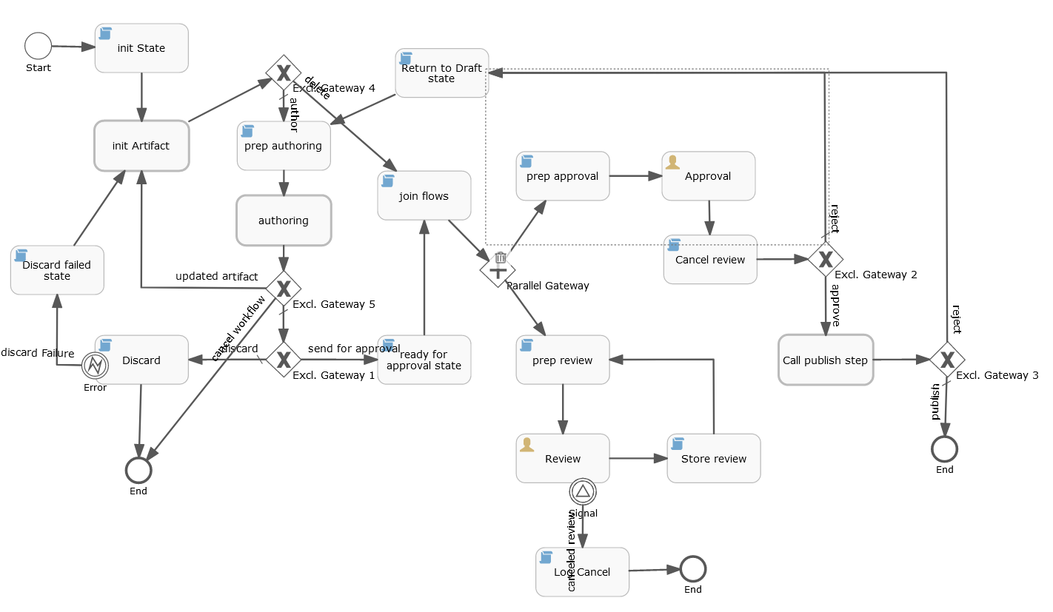

Adding a new User Task “Approval”

Add a new user task by dragging a new user task activity element to the workflow template. Since we intend to chain the approvals, it might make sense to position the new approval element close to the approval element already existing in the workflow.

The new user task now requires a few properties to be defined:

* As an ID, provide a new unique ID, e.g. “approval_2”.   
  This ID is used for internal purposes only and will not be shown to the end user during the workflow management or execution.
* As the “Name” property, provide a new name for the user task, e.g. “Approval 2”  
   This name is used for the display of the user task within the visual workflow editor only. It will not be shown to the end user during the workflow management or execution.  
  However, this name will be used to sort the steps lexicographically when configuring the workflow.
* As the “Category” property, enter “approval”.
* Verify that the property “Exclusive” is checked.
* As the “Due Date” property, enter the following JUEL term: “${approval_due_date}”. The contents of this variable will be set in the “Prep Approval 2” script task below.
* As the “Form properties”, edit the value for “Form properties” and create three new values:
  + “comment” of type string
  + “due_date” of type date
  + “action” of type “enum” and make sure that this “action” is checked with “Required”.  
    For this action you must also create four enum values:
    - An id “approve” with the name “Approve” which will result in a display button with this name.
    - An id “reject” with the name "Reject" which will result in a display button with this name.
    - An id “publish” with the name "Publish" which will result in a display button with this name.
    - an id “delete” with the name "Delete" which will result in a display button with this name.

This will result in four different user buttons which allow the user to either “Approve”, “Reject”, “Publish” or “Delete” the artifact during the workflow execution.

* Due to a restriction in the BPMN format, the “Documentation” property will be used to define a set of values that are picked up by IBM_PRODUCT_NAME in order to visualize the workflow for the end user during the workflow’s execution.  
   All these different values will have to be stored in the “Documentation” property of the user task element as one string where each value is separated by a “$$$” sequence from the next value. The values that must be set are:
  1. The task title: The title that will be shown to the end user during the workflow execution, e.g. “*Approve (fiscal) ${artifact_name}*”
  2. The task instructions: A set of instructions that will be shown to the end user for this task during the workflow execution, e.g. “*Review this document and then approve or reject it.*”
  3. The step instructions: A set of instructions that will be shown to the workflow administrator for this workflow task during the workflow configuration, e.g. “*Add at least one assignee to approve or reject artifacts.”*
  4. The step title: The title that will be shown to the workflow administrator for this workflow task during the workflow configuration, e.g. “*Approval by Finance ${artifact_name}”*

Using the textual examples from above, the complete textual value for the documentation property of this new user task element would be:

“*Approve by Finance $$$Review this document and then approve or reject it.$$$Add at least one assignee to approve or reject artifacts.$$$Approval (fiscal)”*

Note that the “$$$” sequence is separating the four individual values from each other and that the sequence of the individual values is always fixed and that values must be specified according to the sequence above (1. task title, 2. task instructions, 3. step instructions, 4. step title).  
Also note, that you can use variables within these values. Variables will then be substituted by their corresponding value during the execution of the workflow. The variable ${artifact_name} will be replaced by the name of the artifact in progress during the workflow execution. A variable must always have the form “${varname}” where “varname” is the name of the variable. The complete variable term will be replaced by the actual value for the variable “varname” during the execution of the workflow. For a complete list of all Variables, see list above.

### Adding a new Script Task “Prep approval 2”

In order to prepare the actions in the new “Approval 2” user task, we must also add a new script task which will contain the necessary JavaScript code for our second approval user task.

We do this by copying the existing “Prep approval” script task to a new instance and give it the name “Prep approval 2”. Also, a new ID must be provided for this new node, e.g. “prep_approval_2”.

Since we have created a copy of the original “Prep approval” script task, we have also created a copy of the original JavaScript code. However, for our purpose we must slightly modify the code on the new “Prep approval 2” script task from the original code on “Prep approval”:

* As an ID, provide a new unique ID, e.g. “prep_approval_2”.   
  This ID is used for internal purposes only and will not be shown to the end user during the workflow management or execution.
* As the “Name” property, provide a new name for the script task, e.g. “Prep approval 2”  
  This name is used for internal purposes only and will not be shown to the end user during the workflow management or execution.
* As the “Script format” property, make sure to have specified “javascript” as a value.
* Verify that the property “Is Executable” is checked.
* Edit the “Script” property and insert the following JavaScript code at the beginning of the script before the original script:  
    
  scriptLogger.info(execution, execution.getProcessDefinitionId() + ': action ' + action + ' comment ' + comment + ' due date ' + due_date);  
  workflowStateAndActionLogger.updateWorkflowState(execution, 'Ready for fiscal approval', 'Approve', true, comment, null);  
    
  // make a copy of the due_date so the due date of review task can be set properly,  
  // this is required as the due_date will be set to null later so there is no initial value  
  // of the form property due_date for Approval 2 task.  
  // it has to be set as process variable instead of transient local variable as the new  
  // Review task is in a different execution and cannot read transient local variable created  
  // in current execution.  
  execution.setVariable('review_due_date', due_date);

This will ensure that the second approval works similar to the first approval user task with slightly different instructions displayed to the user. During the JavaScript code of this script task the “approval_due_date” variable (and a few others) will be set as preparation for the “Approval 2” user task.

### Connecting the new “Approval 2” user task

The new “Approval 2” user task must now be integrated into the existing workflow. Since we plan to cascade the approvals, the new approval task (financial approval in our example) should be second after the first approval (technical approval in our example). Hence, we need to connect the first approval with the second approval by using a cascaded “exclusive gateway”: Only if the first approval was successful (“approved”) we ask for the second approval.

In our example we do this by inserting a new exclusive gateway element and redirecting the “approve” sequence flow from the first “Approval” user task to a new “Excl. Gateway 6”. From there we continue the approval flow to our new “Prep approval 2” script task immediately followed by our new “Approval 2” user task. From there we cascade to the original gateway “Excl. Gateway 2” which in itself flows to either the publishing step or back to the “Return to Draft state” script task.

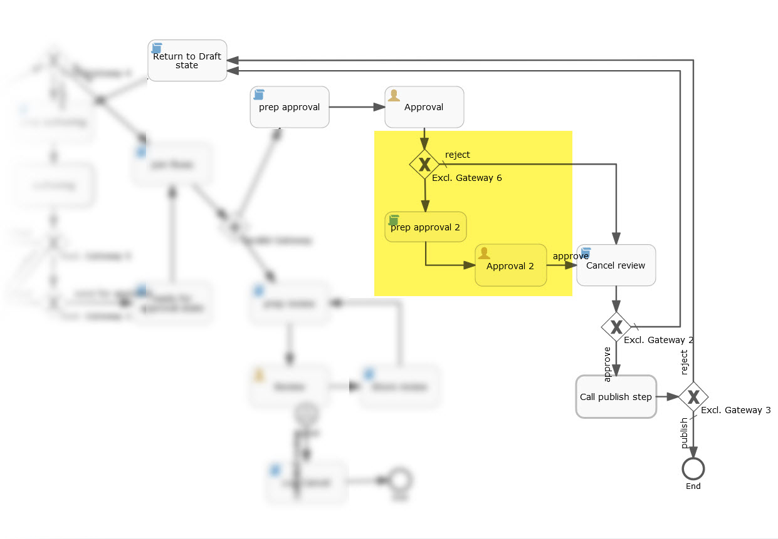

At the end of the approval process, the review flow that was launched by a parallel gateway earlier must be terminated by the “Cancel Review” script task. So both the outcome of “Approval” and the “Approval 2” user tasks must flow to the “Cancel Review” script task. The script in that task will merely terminate the review cycle but not change the action that was set by the previous user task. Hence, the “Cancel Review” script task can be called from both an “Approval” user task with a “reject” action and an “Approval 2” user task with an “approve” action.

Next then is the existing “Excl. Gateway 3” which will branch to either the call to publishing (with an action of “approve”) or back to the artifact’s draft state as the default flow (which includes an action of “reject”).

The new gateway (“Excl. Gateway 6”) must be added by dragging a new exclusive gateway element to the workflow template. The new exclusive gateway then requires a few properties to be defined:

* As an ID, provide a new unique ID, e.g. “exclusive_gateway_6”.   
  This ID is used for internal purposes only and will not be shown to the end user during the workflow management or execution.
* As the “Name” property, provide a new name for the task, e.g. “Excl. Gateway 6”  
   This name is used for the display of the user task within the visual workflow editor only. It will not be shown to the end user during the workflow management or execution.
* The exclusive gateway requires two outgoing sequence flows:
  + One sequence flow (“reject”) to the “Cancel review” script task. This is the default flow.  
    Make sure to give this sequence flow a unique ID and select the “Default flow” property. This will ensure that the flow will be taken in the case of a non-approval.
  + One sequence flow (“approve”) to the new “Prep Approval 2” script task.  
    Make sure to give this sequence flow a unique ID and define a flow condition for this sequence flow by adding the following JUEL script code to the flow condition property:  
    ${action == 'approve' || action == 'publish' || action == 'delete'}  
    This will ensure that the flow will be executed for the corresponding actions and not be executed in the case of a ‘reject’ action.

Now connect the previously created “Prep Approval 2” script task with the newly created “Approval 2” user task and then connect the newly created “Approval 2” user task with the “Cancel review” script task each time by adding a corresponding sequence flow and giving it a unique ID.

The existing “Excl. Gateway 2” already flows to the “Call publish step” call activity in the case of an “approve” action or it branches back to the “Return to Draft state” script task with the default flow which includes a “reject” action.

### Completing and saving your work

Before saving the new template, you should run the workflow editor’s validation functionality in order to detect any errors or problems that you might have created during your workflow template remodeling. It is recommended to fix any errors or issues that are reported during the validation step before using the template in IBM_PRODUCT_NAME.

Since you used the original template “ApprovalAndReview.bpmn” as a base for your work, you should make sure to save your work under a new name in order to be able to distinguish it from the base template and all other templates. For this, you must not only save your work with a new filename, e.g. “Two step approval and review.bpmn” but also you must rename the template’s ID (key) accordingly:

In the your workflow editor, click on the template’s background to get to the template’s main properties. Change the ‘Process Identifier’ property and the ‘Name’ property accordingly.

Then save your workflow template using the workflow editor’s save function and check that your changed ID determines a key for the template: In the Save dialog, you should make sure that the template’s name and key is what you have specified and intended before and that a new key is used for this new template.

### Running the new template in IBM_PRODUCT_NAME

Your new template can now be imported into the IBM_PRODUCT_NAME and activated as a new workflow configuration by the workflow administrator:  
Login to Cloud Pak for Data and navigate to Workflow Types, select “Governance artifact management" and select the tab “Templates”. Here you can import the new template. Then you can create new workflow configurations using this workflow template.